HOUGH TRANSFORM

|  |  |  |  |  |
| --- | --- | --- | --- | --- |
|  |  |  |  |  |
|  |  |  |  |  |
|  |  |  |  |  |
|  |  |  |  |  |
|  |  |  |  |  |

5 X 5 IMAGE

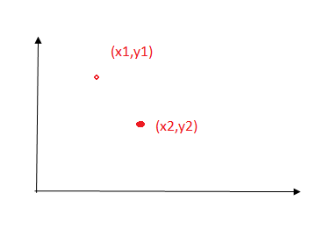

$$\frac{y-y1}{y1-y2}=\frac{x-x1}{x1-x2}$$

Y= mx+c

Y= ax+b

b= -ax+y

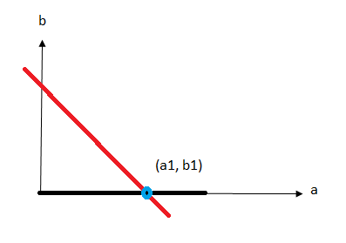

**(x1,y1) = (1,5)**

**b = -a+5**

**(x2,y2) = (0,0)**